INSTRUCTIONS FOR AUTHORS

FORMATTING GUIDELINES

UDC (UNIVERSAL DECIMAL CLASSIFICATION)
Author(s) of the Article
Place of employment
Article Title
Annotation (not less than 1800 characters).
Keywords: (don’t use bold),

Paragraph

Unit
According to the requirements of the Higher Certification Commission of Ukraine to research papers the following obligatory elements must be included to the article structure:
- Statement of the problem in general outline and its connection with important scientific and practical tasks;
- Analysis of the latest researches and publications, in which solution of a problem is initiated and which serve as a background for the author’s research;
- Sorting out of unsolved aspects of the general problem, which the article covers;
- Statement of the object of article (problem definition);
- Summary of the basic material of research with complete argumentation of the obtained scientific results;
- Conclusions of the given study;
- Prospects of the further research work in this area.
Bibliographic references should be given in square brackets. List of references in source language should be placed at the end in a single space from the text of the article, without any additional headings.

Table № 1.
Name of the Table
Column 1 | Column 2 | Column 3

Formulas and images should be in electronic format. Images should be grouped and placed inside the text. The images should be created in GIF or JPEG graphic format.

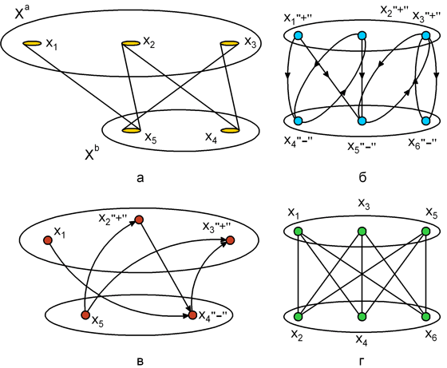
Fig. 1. Name of the image (inscriptions to images, schemes, tables should include an order number, name and a key to conventional signs)

References
(in APA style)

Автор(и) Статті
Місце роботи
назва статті
Анотація українською мовою (не менше 1800 символів)
Ключові слова: (не виділяти жирним),

Authors’ name, title, position, organization, e-mail address, ORCID ID.
Прізвище ім’я по батькові, вчене звання, вчений ступень, посада, місце роботи, адреса електронної пошти, ORCID ID.
Фамилия имя отчество, ученое звание, ученая степень, должность, место работы, адрес электронной почты, ORCID ID.

